**The University of Nottingham**

**Faculty of Engineering**

**Department of Electrical and Electronic Engineering**



**EEEE3026**

**Project Outline and Planning Report**

**WellnessAI+: Elevating Mental, Emotional and Physical Health with ECG-Enhanced Artificial intelligence**

AUTHOR : KOAY XIAN CONG

ID : 20418760

SUPERVISOR : DR HERMAWAN NUGROHO

MODERATOR : PROF T. NANDHA KUMAR

DATE : 30th OCT 2023

**Contents**

1. Overview of the Project 3

2. Specification 5

3. Methodology 6

3.1 Setting up software and hardware for STM32MP157F-DK2. 6

3.2 Integrating ECG kit onto edge computer. 6

3.3 Open-Source AI Model Development. 6

3.4 Model Optimizer and Hardware Accelerator. 6

3.5 Deployment of AI models into edge computers and cloud computers. 6

4. Risk Management and Mitigations 7

5. Time Plan 8

6. References 9

7. Appendix 11

# Overview of the Project

**Introduction**

The focus of this project is to incorporate electrocardiogram (ECG) and artificial intelligence (AI) driven algorithms to offer a groundbreaking approach to edge computing to not only predict heart disease but also delve into the depths of human emotions. This dual-purpose capability signifies a pivotal leap forward in personalized healthcare and wellness management, ushering in a new era of preventative and predictive medicine. The deployment of AI into edge computers powered by ARM Cortex-M chips will also be further explored and discussed.

**Problem Statement**

According to the World Health Organization (WHO), depression stands out as a major contributor to disability, while suicide ranks fourth leading cause of death among individuals aged 15 to 29. [1] An electroencephalogram (EEG) is a commonly utilized tool to diagnose and assess the brain's electrical activity by applying electrodes to the scalp to detect and observe the electrical signals and activity patterns in the brain. Since EEG electrodes need to have good contact with the scalp to capture accurate brainwave data, achieving consistent and reliable contact with the scalp is difficult in a wearable form factor. Movements and shifts in the device, as well as hair interference, can affect the quality of EEG signals. EEG devices may be uncomfortable, inconvenient and expensive for regular use. [2] Mental health aside, cardiovascular disease (CVDs) stands as the primary global cause of mortality, claiming around 17.9 million lives annually according to WHO. [3] An electrocardiogram (ECG) can perform an examination that records the heart’s electrical pulses over a period. These signals are then transmitted to an ECG sensor, which produces a graphical representation of the heart’s electrical activity, often displayed as a graph or a series of waveforms. ECG can provide vital information about various aspects of cardiac health, including heart rate, the regularity of heartbeats, signs of abnormal rhythms, and the presence of certain heart conditions, such as arrhythmia ischemia or structural abnormalities. [4] One of the approaches to detect arrhythmia is to use ECG. [5] Arrhythmia refers to an irregular or abnormal heartbeat. [6] The heart typically beats in a regular, rhythmic pattern to pump blood throughout the body which can be shown in the ECG waveform in Figure 1. In instances of arrhythmia, the heart can exhibit deviations in its rhythm, which may denote excessive speed, rhythm or irregular pattern. [7] Arrhythmias may lead to symptoms such as palpitations, dizziness, breathlessness, or chest discomfort. [8] Thus, accurate diagnosis and monitoring of arrhythmias are essential to maintain good heart health.

**Background Information**

An ECG is utilized as a medical instrument for the heart’s electrical activity measurement and records over a period. A sample signal of the ECG wave is shown in Figure 1. The P-wave represents the electrical signal when the atria contract and push blood into the ventricles. [9] The inter-beat interval (IBI) is used for detecting heart rate, which can be computed based on the distance between R peaks in the ECG waveforms. [10] The QRS complex represents the electrical activity during the ventricles' contraction, which occurs as they pump blood out to circulate through the body. [9] Finally, the T-wave is the recovery phase. The standard placement of ECG is shown in Figure 2. According to Anatomy and Physiology 2, there are physiological interrelations between the heart and brain. [11] The autonomic innervation of the heart is a crucial part of the Autonomic Nervous System (ANS), which regulates involuntary bodily functions, including heart rate, blood pressure and respiratory rate. The regulation of heart rate is centred in the paired cardiovascular control centres within the medulla oblongata of the nervous system which are the sympathetic nervous system and the parasympathetic nervous system as shown in Figure 3. [11] While at rest, both centres offer subtle stimulation to the heart, contributing to the autonomic tone. The cardio accelerator triggers the release of the neurotransmitter norepinephrine, leading to a significant rise in heart rate, which takes place in both the sympathetic nervous system (SNS) and the sinoatrial (SA) node, while the cardioinhibitory release the neurotransmitter acetylcholine (Ach) into the parasympathetic nervous system (PNS). [11] The ANS would react based on the situation and alterations in the emotional experiences. For instance, a cardioaccelerator will be triggered in a “flight-or-fight” situation [12] whenever a person is in danger. Based on a national survey performed in the US, roughly 30% of American adults make use of healthcare wearable devices. [13] Among these users, about 47.33% use these devices daily, and a significant majority, representing 82.38%, express their willingness to share the health data collected from these wearables with their healthcare providers, emphasizing the potential for healthcare professionals to access vital information for better-informed medical decisions. [13] Thus, it reveals a compelling case for the development and commercialization of healthcare wearables which ultimately enhance the overall quality of healthcare services.

**Aim**

The objective of this project is to create a health monitoring system that integrates an ECG measurement kit with an STM32 edge computer and a cloud-based computer. This system comprises two key components: a model for predicting heart disease (cloud computer) and another for real-time emotion recognition (edge computer). The most important goal is to design an electronic circuit which is capable of precisely capturing bioelectric signals from the heart. Next, a data processing technique for obtaining characteristics that hold physiological and physical importance needs to be designed. [2] Additionally, the project explores the utilization of STM32 X-Linux-AI, facilitating the deployment of AI models into the embedded system. The model needs to be lightweight to be embedded into a device to implement edge computing. [2] [9]

# Specification

|  |  |  |  |  |  |
| --- | --- | --- | --- | --- | --- |
| **Requirements** | **Priority** | **Standards & Practices** | **Tests** | **Success Measure** | **Attainability & Achievability** |
| **Hardware** | | | | | |
| Integrating ECG measurement kit onto edge computer. | High | Ensure secure and accurate data transmission, and compliance with medical data protection standards. | Verify data connection between the ECG kit and edge computer. | Successful integration with consistent, accurate ECG data transmission. | Achievable with appropriate hardware interfaces and software development. |
| Create a real-life model of the wearable designed to integrate both software and hardware onto it. | Low (Stretch goal) | Utilize ergonomic design to ensure user comfort and safety. | Conduct usability tests with potential users. | Positive feedback from users on functionality and design. | Challenging but attainable as a stretch goal, may require additional resources and time. |
| **Software** | | | | | |
| Coding program to connect ECG sensor with edge computer. | Medium | Adhere to coding and programming best practices, ensure modularity and standardization of code, and follow any relevant licenses for code libraries. Use open-source libraries. | Conduct tests and experiments to verify the accuracy and reliability of sensor data. | A program that effectively tests the ECG sensor and provides reliable data. | Achievable with the necessary programming skills and resources. |
| Coding program to create, test and heart disease prediction model. | High | Conduct tests to verify the accuracy and effectiveness of the heart disease prediction. | A functional program that successfully creates and tests the heart disease prediction model. |
| Coding program to create, test and deploy emotion recognition model. | High | Conduct tests to verify the accuracy and effectiveness of the emotion recognition. | A functional program that successfully creates and tests the emotion recognition model. |
| Coding program to display data collected from sensor and model output. | Low (Stretch goal) | Validate the program’s ability to display sensor data and model output results effectively. | Development of a program that successfully displays sensor data and model output results. | Achievable as a stretch goal, may require additional software development resources. |

# Methodology

## 3.1 Setting up software and hardware for STM32MP157F-DK2.

STM32MP157F-DK2 [14] is power-efficient and suitable for real-time tasks which are designed for low power consumption, making it well-suited for wearable devices. The presence of an ARM Cortex-M4 microcontroller on the edge computer allows for real-time control, which can be crucial for the deployment of real-time emotion recognition. It comes with 4” TFT 480x800 pixels, allowing data and model output to be displayed. However, compared to Raspberry Pi, it has fewer readily available resources and support due to smaller communities. STM32 Cube programmer [14] is part of the STM32Cube ecosystem, which provides a comprehensive set of development tools for STM32 microcontrollers and microprocessors. However, STM32 Cube Programmer can be resource-intensive, particularly when working with large projects. The potential additional task includes familiarizing with Ubuntu OS and STM32 Cube programmer.

## 3.2 Integrating ECG kit onto edge computer.

AD8232 ECG measurement kit [15] is chosen for its precision in collecting vital heart activity. However, wearable ECG sensors may not be as comfortable for long-term use, potentially affecting user adoption and compliance. The potential additional tasks include performing tests and experiments to verify that the ECG kit is functioning correctly and can collect ECG data accurately and implementation of data transmission protocols to ensure that ECG data collected by the kit can be transmitted to the edge computer in real time.

## 3.3 Open-Source AI Model Development.

Python is a widely used programming language for ML and DL. It has various libraries available for data manipulation, analysis, visualization, etc in AI model development. However, advanced DL models may require substantial computational resources, which could impact performance on resource-constraints systems. Anaconda provides a convenient environment for managing Python packages and creating isolated development environments. Since there are 2 models developed: heart disease prediction and emotion recognition, this feature ensures package compatibility between projects. Deep learning libraries (TensorFlow Lite etc.) enable AI model development more accessible and efficient with optimization tools and GPU acceleration available. Git/GitHub is a version control system that allows for efficient version tracking in AI model development. The potential additional tasks include familiarization with software tools and DL models, and performing data preprocessing, which may involve tasks like data augmentation, normalization and retraining models available online to validate the model's accuracy and performance.

## 3.4 Model Optimizer and Hardware Accelerator.

STM32 X-LINUX-AI is an expansion package that targets artificial intelligence for STM32MP1 series microprocessors. There are limited model architectures available.

## Deployment of AI models into edge computers and cloud computers.

Cloud platforms like AWS offer access to powerful GPU instances, which significantly accelerate AI model inference and training. It also offers APIs to link the results to front-end web/mobile apps. However, AI models deployed in the cloud may experience network latency, which can be a concern for real-time applications. The potential additional task includes ensuring that the AI models are optimized for deployment on both the edge and cloud platforms.

# Risk Management and Mitigations

**Importance = Severity + Likelihood [Low = 1, Medium = 2, High = 3]. The higher the value, the more important the risk.

|  |  |  |  |  |  |  |
| --- | --- | --- | --- | --- | --- | --- |
| **Events** | **Timeline**  **(Week)** | **Risks** | **Mitigation** | **Impact** | **Pre, Post Mitigation Severity & Likelihood** | **\*\*** |
| Integrating ECG kit onto edge computer. | 10 – 14 | Incompatibility issue between edge computer and ECG measurement kit. | Perform compatibility testing and refer to hardware documentation. | Delay in project timeline. | *Pre:* Low  *Post:* Low  *Likelihood:*  Low | 3 |
| Short circuit due to incorrect power connections. | Adhering to the documentation and requirements. | Delay in project timeline if new microcontroller order is needed. | *Pre:* Medium  *Post:* Low  *Likelihood:*  Low | 4 |
| Open-Source AI Model Development | 14 – 28 | Advanced deep learning models may require substantial computational resources, impacting performance on resource-constrained systems. | Optimize and simplify AI models, employ cloud-based resources when necessary, and manage hardware efficiently. | Delayed model training. Performance degradation. | *Pre:* Medium  *Post:* Medium  *Likelihood:*  High | 7 |
| An exclusive reliance on deep learning methods proved insufficient in identifying all crucial ECG signal features. [9] [7] | A hybrid strategy is applied to improve detection efficiency. [9] | Inaccurate results. Misdiagnoses. | *Pre:* High  *Post:* Medium  *Likelihood:*  High | 8 |
| ECG signal analysis demands a substantial volume of data for accurate results. [7] | Performing data augmentation to increase the size of the dataset available. | Inaccurate results. Misdiagnoses. | *Pre:* High  *Post:* Medium  *Likelihood:*  High | 8 |
| Deployment of AI models into edge computer and cloud computer | 27 – 31 | The model takes too long to produce output. | Rigorously test AI model deployment on the edge computer to ensure real-time performance and functionality. | Model inaccuracies and reduced usability. | *Pre:* High  *Post:* High  *Likelihood:*  High | 9 |
| API and model compatibility issues. | Perform test cases with available AI models before training a new model. | Delay in project timeline. | *Pre:* High  *Post:* Medium  *Likelihood:*  High | 8 |
| Network latency when deployed in the cloud. | Optimize model size. | Delayed response time. | *Pre:* High  *Post:* Medium  *Likelihood:*  High | 8 |

# Time Plan

The Gantt Chart for time planning has been structured considering the interdependencies between tasks. Within the "Design solutions/applications" phase, there's a requirement to set up and test ECG sensors, STM32MP157F, and software. This precedes the design of the model architecture before moving on to the development of the AI model. The deployment of the model and sensor hinges on the completion of the AI model, so it follows this phase. To ensure tasks stay on track, there are project milestones marked at various points, and four progress reviews are scheduled:

Moderator Review 1 is planned between Week 9 – Week 10 to discuss project objectives and project specifications. Moderator Review 2 planned between Week 13 – Week 14 is to discuss the process made upon a program that tests functions of edge computers and experiments made to ensure accurate measurements of sensors. Moderator Review 3 planned for Week 25 is to discuss the development and progress of the emotion recognition model, heart disease prediction model and program that connects sensors with AI model. Moderator Review 4, which is planned between Week 35 – Week 36 is to discuss the deployment of the heart disease prediction model developed onto a cloud computer and, the deployment of the emotion recognition model developed onto the edge computer. In light of the potential risks and issues mentioned earlier, a parallelization technique is applied to enable the execution of multiple tasks simultaneously, particularly those that are independent of one another. Additionally, provisions have been made for debugging codes and addressing bugs that may surface during model development and user testing. Improvements can be made based on feedback obtained from users. The Gantt chart also incorporates error bars to account for uncertainties. In cases where previously unidentified risks arise, these error bars provide additional time to mitigate the issues. Lastly, the Gantt chart includes optional and supplementary tasks, described as stretch goals, which can be pursued if there is available time before each progress review.

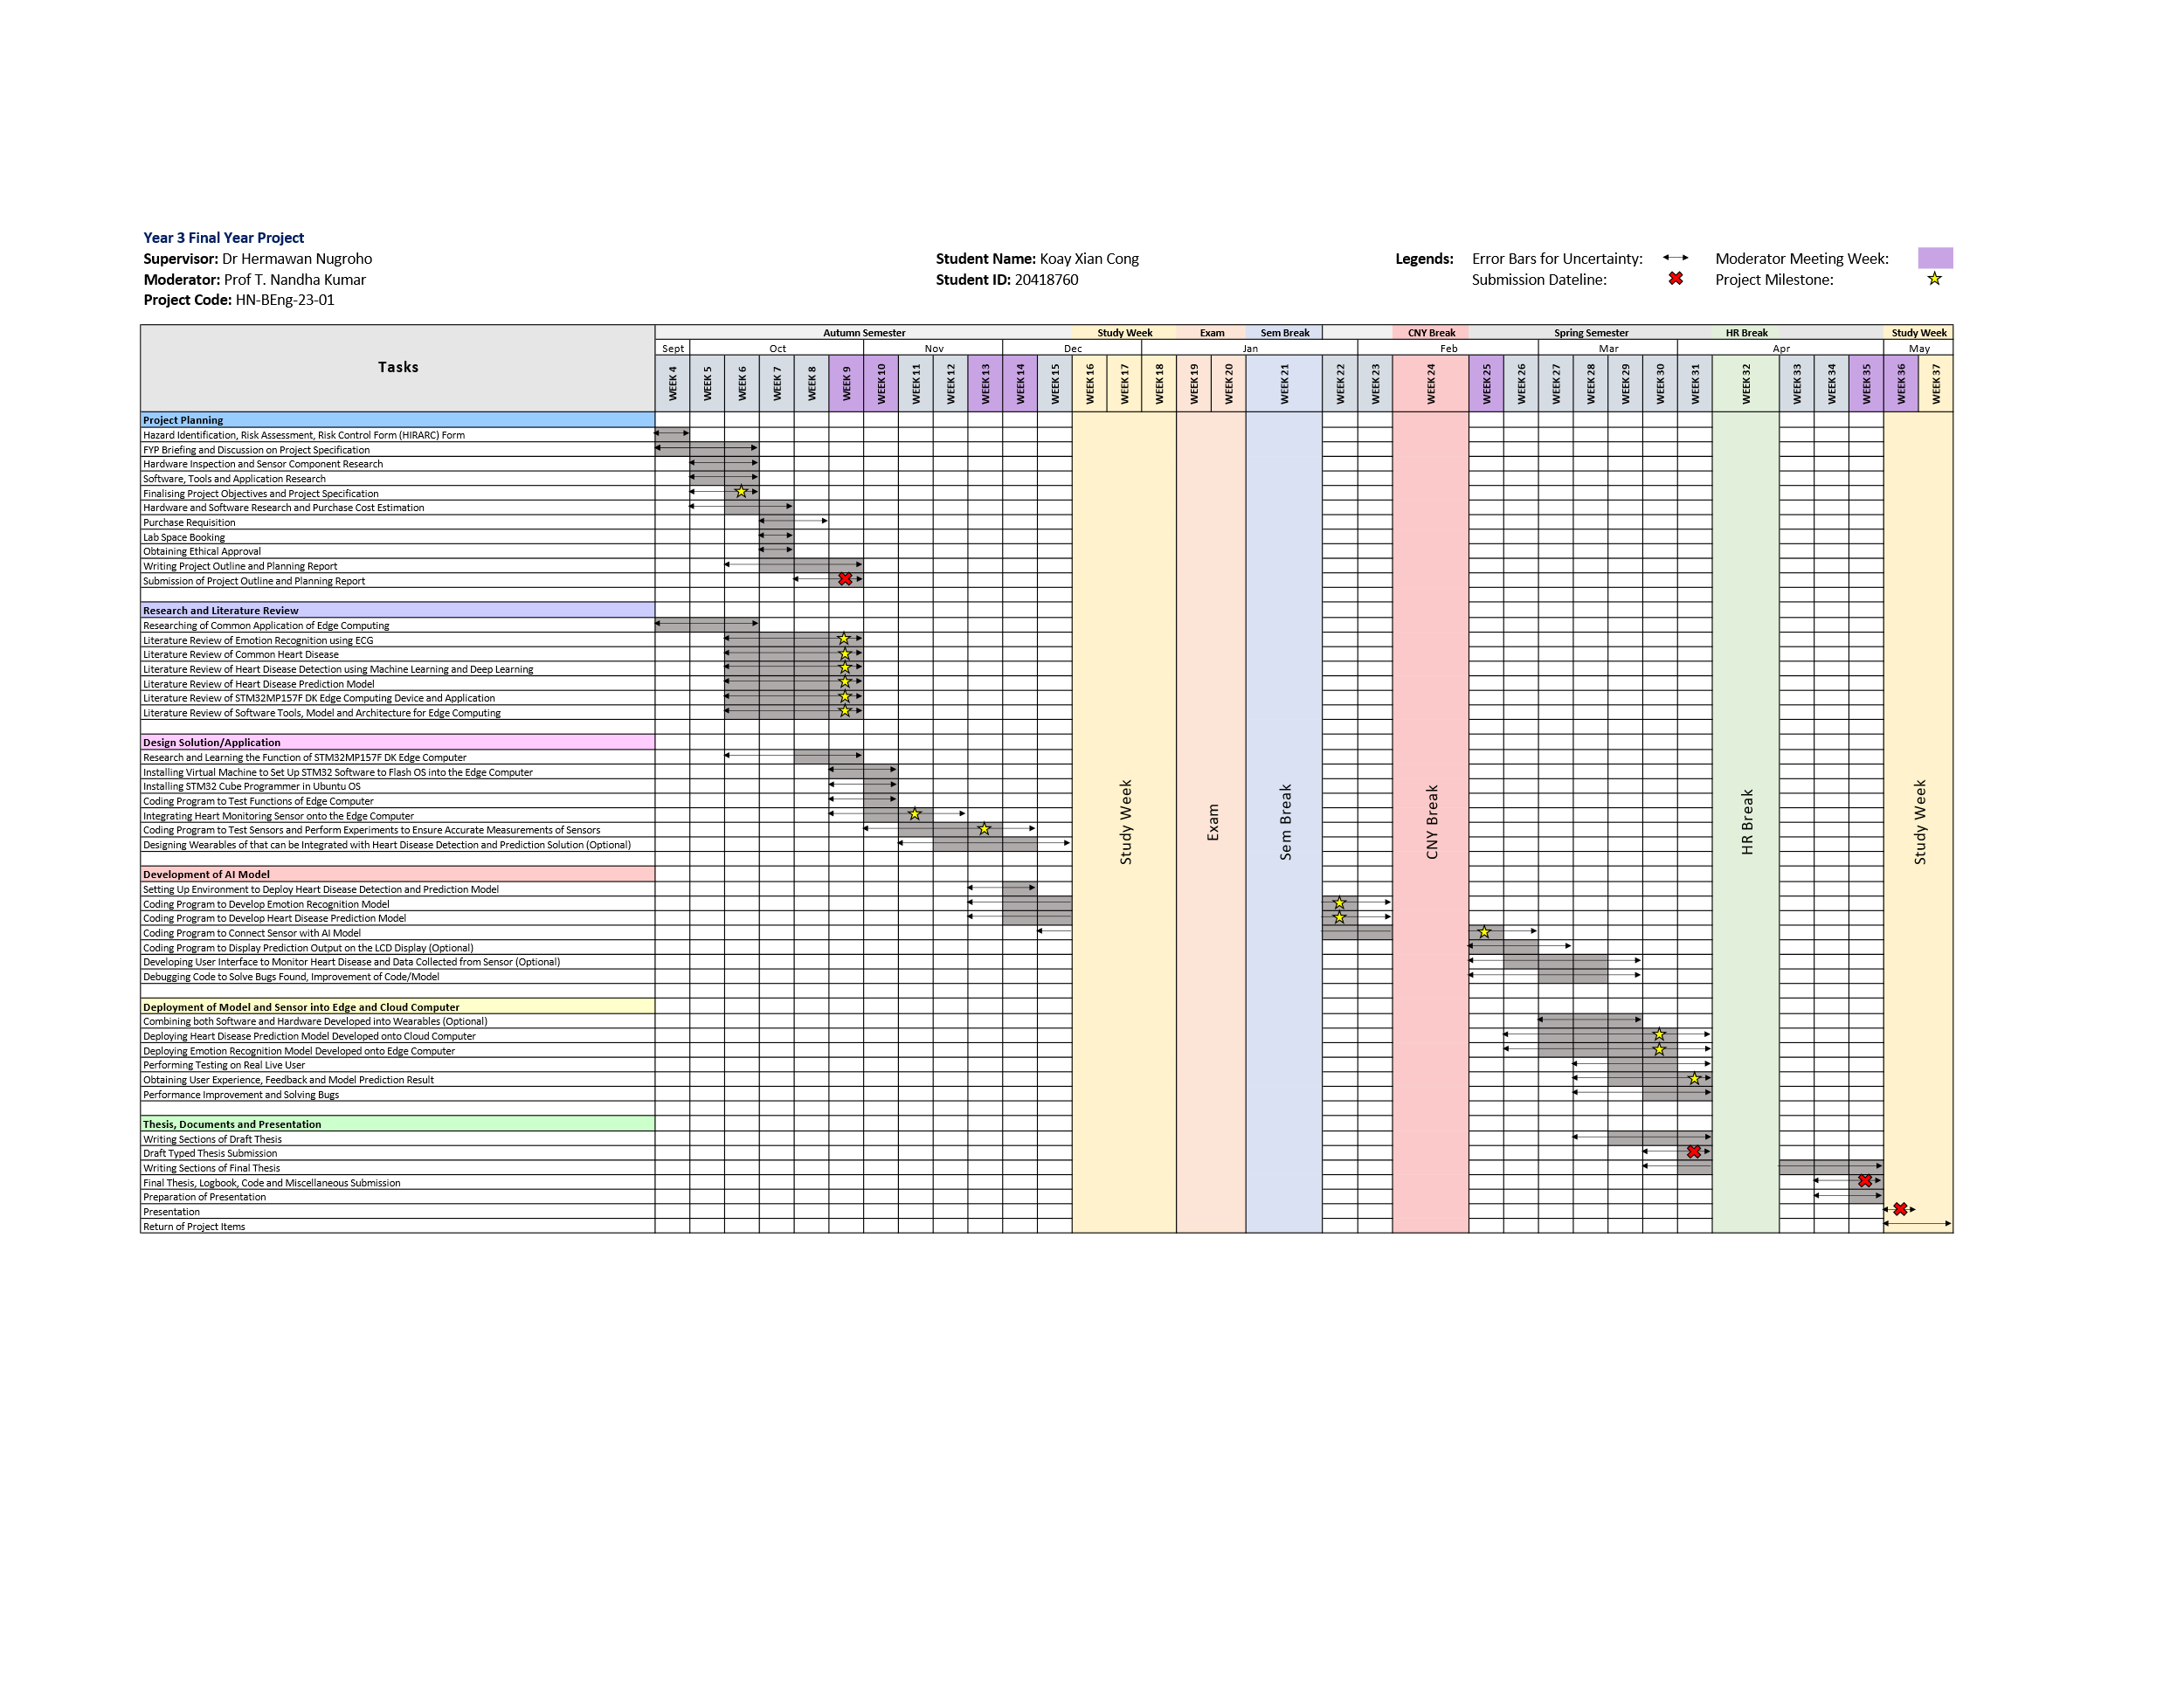**Gantt Chart**

# References

[1] “Mental health.” Accessed: Oct. 19, 2023. [Online]. Available: https://www.who.int/health-topics/mental-health#tab=tab_1

[2] X. Wang, J. Zhang, C. He, H. Wu, and L. Cheng, “A Novel Emotion Recognition Method Based on the Feature Fusion of Single-Lead EEG and ECG Signals,” *IEEE Internet Things J*, 2023, doi: 10.1109/JIOT.2023.3320269.

[3] “Cardiovascular diseases.” Accessed: Oct. 19, 2023. [Online]. Available: https://www.who.int/health-topics/cardiovascular-diseases#tab=tab_1

[4] Ed Burns and Mike Cadogan, “Myocardial Ischaemia • LITFL • ECG Library Diagnosis.” Accessed: Oct. 19, 2023. [Online]. Available: https://litfl.com/myocardial-ischaemia-ecg-library/

[5] H. Yang and Z. Wei, “Arrhythmia Recognition and Classification Using Combined Parametric and Visual Pattern Features of ECG Morphology,” *IEEE Access*, vol. 8, 2020, doi: 10.1109/ACCESS.2020.2979256.

[6] K. Subramanian and N. K. Prakash, “Machine learning based cardiac arrhythmia detection from ECG signal,” in *Proceedings of the 3rd International Conference on Smart Systems and Inventive Technology, ICSSIT 2020*, 2020. doi: 10.1109/ICSSIT48917.2020.9214077.

[7] T. Padma, A. Uday Kiran, C. Jahnavi, S. Rahul, N. Raja, and M. Kamal Kumar, “Detection and Classification of Arrhythmias by Deploying Deep Learning Models,” in *Journal of Physics: Conference Series*, 2022. doi: 10.1088/1742-6596/2325/1/012053.

[8] A. A. Salman and A. Ibarahim, “Detection of Cardiac Arrhythmias in Electroc Ardiograms Using Deep Learning,” in *ISMSIT 2022 - 6th International Symposium on Multidisciplinary Studies and Innovative Technologies, Proceedings*, 2022. doi: 10.1109/ISMSIT56059.2022.9932742.

[9] A. L. Golande and T. Pavankumar, “Optical electrocardiogram based heart disease prediction using hybrid deep learning,” *J Big Data*, vol. 10, no. 1, pp. 139–13, 2023, doi: 10.1186/s40537-023-00820-6.

[10] A. Tjolleng *et al.*, “Classification of a Driver’s cognitive workload levels using artificial neural network on ECG signals,” *Appl Ergon*, vol. 59, no. Pt A, pp. 326–332, 2017, doi: 10.1016/j.apergo.2016.09.013.

[11] J. G. Betts *et al.*, *Anatomy & Physiology -OpenStax*. 2013.

[12] P. J. Bota, C. Wang, A. L. N. Fred, and H. Placido Da Silva, “A Review, Current Challenges, and Future Possibilities on Emotion Recognition Using Machine Learning and Physiological Signals,” *IEEE access*, vol. 7, pp. 140990–141020, 2019, doi: 10.1109/ACCESS.2019.2944001.

[13] R. Chandrasekaran, V. Katthula, and E. Moustakas, “Patterns of Use and Key Predictors for the Use of Wearable Health Care Devices by US Adults: Insights from a National Survey,” *Journal of Medical Internet Research*, vol. 22, no. 10. 2020. doi: 10.2196/22443.

[14] “Unpack the STM32MP157x-DK2 board - stm32mpu.” Accessed: Oct. 22, 2023. [Online]. Available: https://wiki.st.com/stm32mpu/wiki/Getting_started/STM32MP1_boards/STM32MP157x-DK2/Let%27s_start/Unpack_the_STM32MP157x-DK2_board

[15] “Ks0261 keyestudio AD8232 ECG Measurement Heart Monitor Sensor Module - Keyestudio Wiki.” Accessed: Oct. 22, 2023. [Online]. Available: https://wiki.keyestudio.com/Ks0261_keyestudio_AD8232_ECG_Measurement_Heart_Monitor_Sensor_Module#Test_Result

[16] J. Gordon Betts *et al.*, *Anatomy and Physiology 2e*. Houston, Texas: OpenStax, 2022.

[17] X. Wang, J. Zhang, C. He, H. Wu, and L. Cheng, “A Novel Emotion Recognition Method Based on the Feature Fusion of Single-Lead EEG and ECG Signals,” *IEEE Internet Things J*, 2023, doi: 10.1109/JIOT.2023.3320269.

[18] M. Roesler, L. Mohimont, F. Alin, N. Gaveau, and L. A. Steffenel, “Deploying Deep Neural Networks on Edge Devices for Grape Segmentation,” in *Communications in Computer and Information Science*, 2021. doi: 10.1007/978-3-030-88259-4_3.

# Appendix

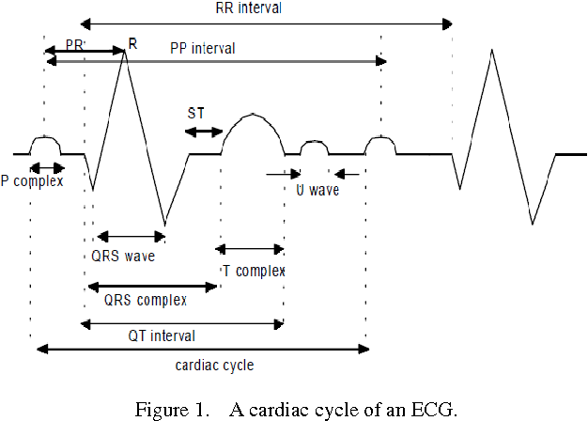

Figure 1. EEG cycle.

Figure 2. Standard placement of ECG. [16]

Figure 3. Autonomic Innervation of the Heart.

**Project Specifications**

|  |  |  |
| --- | --- | --- |
| Project Title |  | Emotion recognition and heart disease detection based on ECG analysis using STM32 MPU. |
| Project Code |  | HN-BEng-23-01 |
| Supervisor |  | Hermawan Nugroho |
| Moderator |  | Prof T. Nandha Kumar |
| Project Description |  | The perception, cognition, and decision-making processes which people engage daily are significantly influenced by their emotions, which is important for human contact and communication. People's numerous physiological signs behave differently depending on how they are feeling. EEG (electroencephalogram) is a typical biological signal utilized for emotion recognition. However, several studies have shown that accurate emotion recognition using multichannel ECG (electrocardiogram) information is possible [1].  STM32 is a family of microcontrollers created by STMicroelectronics. X-LINUX-AI is an STM32 MPU OpenSTLinux Expansion Package that targets artificial intelligence for STM32MPx series devices. It contains Linux AI frameworks, development tools, as well as applications such as computer vision [2].  In the project, the aim is to explore and develop an edge intelligence system which can run emotion recognition and heart disease detection using ECG data.  References:  [1] X. Wang, J. Zhang, C. He, H. Wu, and L. Cheng, “A Novel Emotion Recognition Method Based on the Feature Fusion of Single-Lead EEG and ECG Signals,” *IEEE Internet Things J*, 2023, doi: 10.1109/JIOT.2023.3320269.  [2] M. Roesler, L. Mohimont, F. Alin, N. Gaveau, and L. A. Steffenel, “Deploying Deep Neural Networks on Edge Devices for Grape Segmentation,” in *Communications in Computer and Information Science*, 2021. doi: 10.1007/978-3-030-88259-4_3. |
| Project Objectives |  | 1. Explore and improve algorithms for emotion recognition using ECG data. 2. Explore and improve algorithms for heart disease detection using ECG data. 3. Integrate the emotion recognition module (real time analysis) and heart disease detection (offline analysis). 4. Adopt the developed algorithms on STM32 MPU |
| Project Deliverables |  | 1. Emotion recognition algorithm using ECG data. 2. Heart disease detection using ECG data. 3. STM32 MPU based edge intelligence system. |
| Ratio of HW/SW/Research |  | |  |  |  | | --- | --- | --- | | **HW** | **SW** | **Research/Investigation/Design** | | 20 | 40 | 40 | |
| Lab Space Requirements |  | Fixed Space  Ad-hoc Space  Others. Space in the drone-lab |
| Software  (This is software usually supported in the Software Lab) |  | X-Linux-AI, STM32MX, STM32IDE |